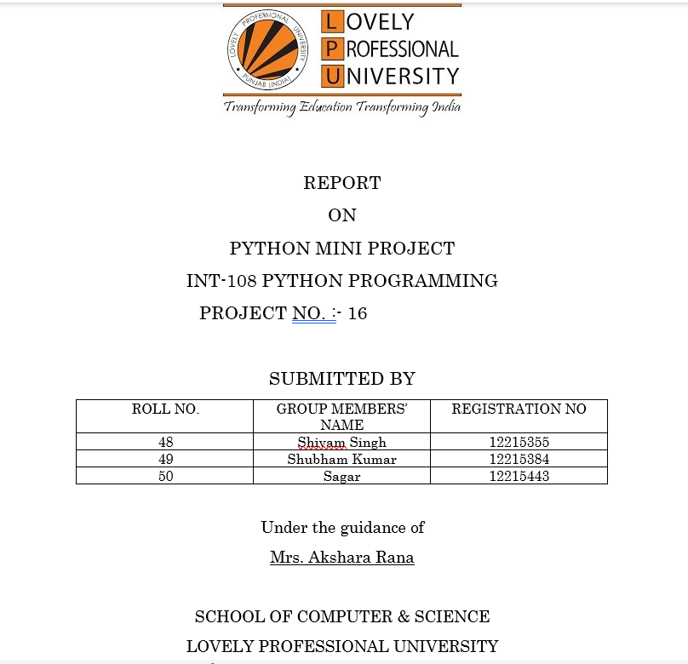

**INTRODUCTION**

Python is a**multi-paradigm programming language**. Object-oriented programming and structured programming are fully supported, and many of their features support functional programming and aspect-oriented programming.

Our mini project is to print how many days the user had lived since his date of birth using python programming language without GUI. In this we have to build text based user interface .

In this mini project user will input two dates:

* His/her date of birth in DD/MM/YY format.
* Current(present day) date in DD/MM/YY format.

In this we are importing date from DateTime from the library.

**OBJECTIVE**

Our main objective is to let the user know how many days that person survived in this world when he inputs two dates , that is his date of birth and the current day.

And our calculation must be accurate and we have consider leap and non leap years separately.

**RESULT SCREENSHOT**

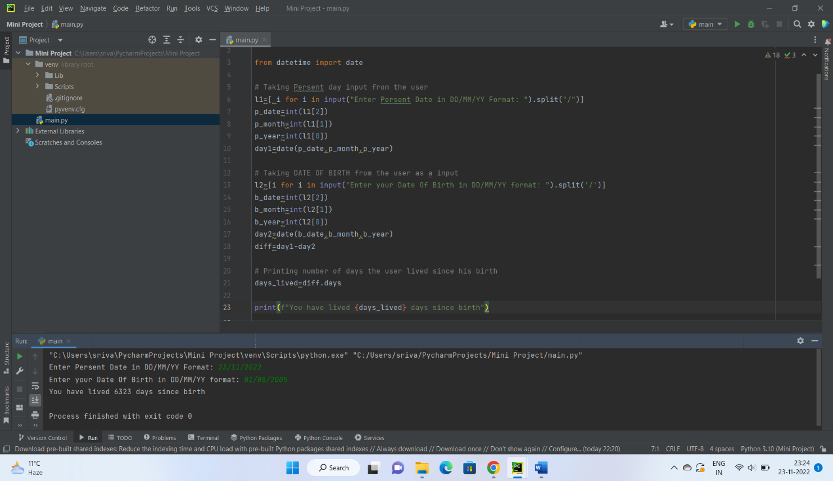

## **CONCLUSION**

From this project we conclude that how we can calculate number of days the user survived since his birth accurately considering leap and non leap year separately .After importing Date from Datetime we can calculate easily. The library of python help easily to do any type of project easily.

**REFERENCES**

* Greeks for greeks
* Github.com